CS-330 Project Proposal

Front 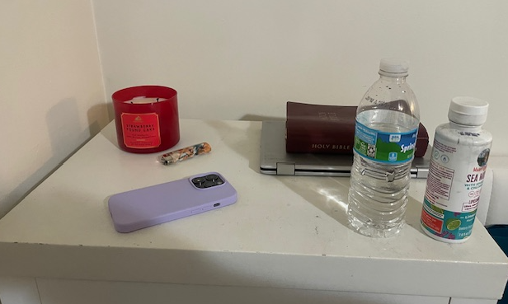

Back 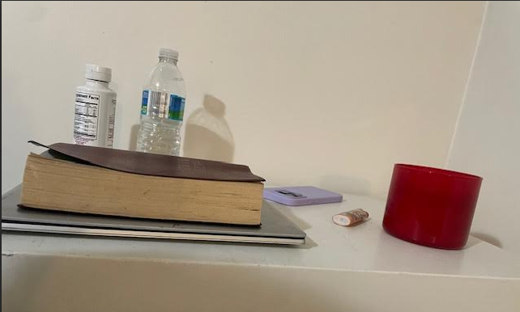

The selected 2D scene is a photograph I took of my nightstand, which includes a laptop, a Bible, a candle, a water bottle, a BIC lighter, a cell phone, and a bottle of liquid sea moss. This scene was chosen because it contains a variety of everyday objects with different shapes, sizes, and materials, making it well suited for replication in a 3D environment. Taking my own photo allows me to clearly observe object placement, scale, and depth, which will help ensure accurate positioning when recreating the scene in OpenGL.
These objects are a good choice for this project because they can be modeled using basic 3D shapes while still demonstrating object composition. The nightstand will be represented using a plane to ground the scene, with a box used to add thickness. The laptop will be modeled using a box for the base and a plane for the screen, while the Bible and cell phone can be represented using scaled boxes. Cylinders will be used for the candle, water bottle, and liquid sea moss bottle, with additional shapes such as cones, spheres, or tapered cylinders used for caps and small details. This approach ensures the use of multiple basic 3D shapes while keeping the scope realistic and achievable.
Overall, the scope of this scene is appropriate for the course and allows for incremental development using translation, rotation, and scaling transformations. The compact layout supports smooth camera movement and lighting adjustments, and textures can be added later to represent materials such as plastic, glass, and paper. This scene balances realism and technical feasibility, providing a strong foundation for the final project.

